**FIFA 2018**

* Based on the player distribution, England emerges as the country with the highest number of players in the dataset. However, it is important to consider the quality and performance of players in addition to their quantity when assessing the competitiveness of national teams.
* A moderate positive correlation between rating and age. It indicates that rating tends to decrease as age increases until around the age of 35. After 35, there is a change in the trend, and rating starts to decrease as age decreases.

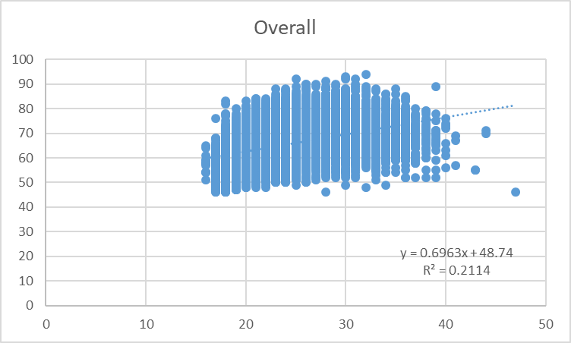

* ST are more paid.
* Overall rating wise preferred positions are ST LW (Striker and Left Wing), RW (Right Wing), ST (Striker), GK (Goalkeeper) and LW (Left Wing).
* Top performers are Cristiano Ronaldo, L. Messi ,Neymar ,L. SuÃ¡rez and M. Neuer.
* Potential wise preferred positions are ST , ST LW , GK, LW and RW.
* Top performers are Cristiano Ronaldo, Neymar,K. MbappÃ©, G. Donnarumma and L. Messi.
* Maximum share of players from England: Shrewsbury

Maximum share of players from Spain: Athletic Club de Bilbao

Maximum share of players from Germany: CA Osasuna

* Potential and wage has moderate correlation.
* CM CDM CB has the highest average aggression.
* Overall and Composure: The correlation coefficient between Overall and Composure is 0.286025319, indicating a moderate positive correlation. This suggests that players with higher levels of composure tend to have higher overall ratings. Composure is an important attribute that reflects a player's ability to remain calm and make good decisions under pressure.
* Ball Control and Balance: The correlation coefficient between Ball control and Balance is 0.631985061, suggesting a moderate positive correlation. This implies that players with better ball control skills often possess good balance, which helps them maintain control while dribbling or receiving the ball.
* Aggression and Agility: The correlation coefficient between Aggression and Agility is 0.015387325, indicating a weak positive correlation. This suggests that there is a minimal relationship between a player's aggression and their agility. Aggression refers to a player's tendency to engage in physical challenges, while agility reflects their ability to quickly change direction and move effectively on the field.
* Overall and Ball Control: The correlation coefficient between Overall and Ball control is 0.104548041, indicating a relatively weak positive correlation. This suggests that while ball control is an important attribute, it is not the sole determinant of a player's overall rating. Other factors, such as shooting ability, passing, and physical attributes, also contribute to a player's overall rating.
* Composure and Ball Control: The correlation coefficient between Composure and Ball control is 0.738490624, indicating a relatively strong positive correlation. This implies that players with good ball control skills tend to also demonstrate higher levels of composure, which can positively impact their decision-making and execution under pressure.
* These insights provide a glimpse into the relationships between the mentioned attributes based on the correlation coefficients. However, it's important to note that correlation does not imply causation, and other factors not included in the correlation matrix may also influence player performance.
* Top 30 clubs based on wages FC Barcelona

Real Madrid CF, FC Bayern Munich, Juventus, Manchester United, Chelsea, Manchester City, Arsenal, Liverpool, Paris Saint-Germain, Everton, Tottenham Hotspur, Milan, Napoli, West Ham United, Roma, Inter, Southampton, Borussia Dortmund, AtlÃ©tico Madrid, FenerbahÃ§e S, Zenit St. Petersburg, Leicester City, Galatasaray S, West Bromwich Albion, Swansea City, Stoe City, BeÅŸitaÅŸ J, Sparta Moscow, Watford.

* Team formation and comparison

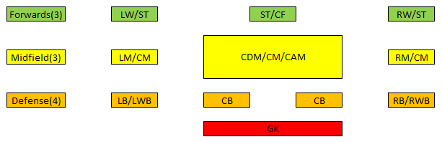

England:

GK: J. Hart (66)

DEF: G. Cahill (84), M. Keane (81), C. Smalling (81), P. Jagielka (80)

MID: R. Mason (75), H. Lansbury (73), H. Winks (72)

FWD: S. Gallagher (75), M. Waghorn (69), N. Ajose (67)

Spain:

GK: De Gea (90)

DEF: Sergio Ramos (90), Piqué (87), Iñigo Martínez (82), Víctor Ruíz (82)

MID: Iniesta (87), Cesc Fàbregas (86), Saúl (82)

FWD: Iago Aspas (83), David Barral (70), Onwu (66)

Italy:

GK: G. Buffon (89)

DEF: G. Chiellini (89), L. Bonucci (88), A. Barzagli (85), F. Acerbi (82)

MID: S. Sturaro (77), L. Mora (71), L. Valzania (68)

FWD: Eder (80), M. Sau (74), F. Dionisi (73)

Germany:

GK: M. Neuer (92)

DEF: J. Boateng (88), M. Hummels (88), S. Mustafi (84), N. Süle (83)

MID: M. Stendera (76), R. Yabo (73), R. Benatelli (68)

FWD: P. Köpke (69), G. Wegkamp (67), R. Sukuta-Pasu (67)

Insights for the coach based on these teams:

Goalkeepers: Germany has the strongest goalkeeper, M. Neuer (92), followed by Spain with De Gea (90), Italy with G. Buffon (89), and England with J. Hart (66).

Defenders: Spain boasts a solid defensive lineup with Sergio Ramos (90), Piqué (87), and experienced players like Chiellini (89) and Bonucci (88) strengthen Italy's defense. England has a balanced defensive lineup, while Germany has strong defenders like Boateng (88) and Hummels (88).

Midfielders: Spain showcases midfield maestros like Iniesta (87) and Cesc Fàbregas (86), while England and Italy have midfielders with decent overall ratings. Germany's midfielders have slightly lower overall ratings in comparison.

Forwards: Germany has a strong attacking lineup with M. Neuer (92) and quality forwards like P. Köpke (69) and G. Wegkamp (67). Spain has a balanced attacking lineup with Iago Aspas (83) leading the way. England and Italy have forwards with relatively lower overall ratings.

Overall Team Strength: Based on overall player ratings, Germany seems to have the strongest team, followed closely by Spain and Italy. England, while having some strong individual players, may face challenges in terms of overall team strength compared to the other countries.

Playing Styles and Tactics: Consider the preferred playing styles and tactical approaches of each team. Spain is known for their possession-based style, Italy for their defensive solidity, Germany for their organized and disciplined approach, and England for their physicality and direct play.